Jess Curtis/Gravity
Media Contact: Mary Carbonara 415/845-9994 or Marycarbonara@gmail.com
FOR IMMEDIATE RELEASE

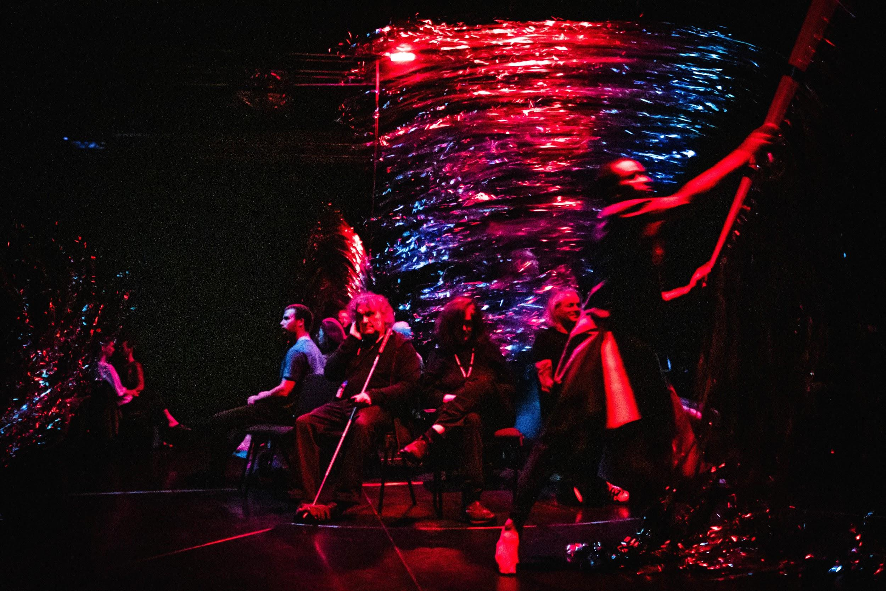
Pictured: Performance of (in)Visible in Berlin, Germany, July 18, 2019; Photo by Sven A Hagolani

Jess Curtis/Gravity presents
(in)Visible

How do you experience a performance?

By seeing it?

What if that’s not possible?

October 3-6 and 10-13, 2019 at CounterPulse in San Francisco
Audio Description, pre-show Touch Tours and ASL interpretation provided.
Tickets and information:
www.jesscurtisgravity.org/invisible or 415-626-2060

August 6, 2019, San Francisco -- Jess Curtis/Gravity announces the San Francisco leg of the rolling World Premiere of (in)Visible, a dance/performance dislocating vision from the center of your experience. Developed in collaboration with—and particularly focusing on access to culture for—blind and visually impaired audiences, (in)Visible is created and performed by an international cast of six blind, visually impaired and sighted body-based dancers/performers. Through dancing, singing, whispering and feeling, they make their way into your consciousness—bringing experimental dance/performance and sensory accessibility practices into a rich and moving interaction. (in)Visible runs two weekends, Thursday to Sunday, October 3-6 and 10-13 at 8:00 pm at CounterPulse in San Francisco. Audio Description is available for every performance. ASL interpretation is available one night per weekend. Please check www.counterpulse.org for specifics. Tickets are $10 to $30 and are available online at www.jesscurtisgravity.org/invisible or by calling 415-626-2060.

Developed in residence at both CounterPulse in San Francisco and at Uferstudios in Berlin, where it premiered July 18, (in)Visible furthers Curtis’ research into the intersections of movement, culture, sensory difference and physical diversity in live performance. Curtis explains, “Specifically, (in)Visible addresses the disproportionate prevalence in our culture of sight as a tool of perception, and explores more diverse modes of perceiving.”

Curtis adds, “(in)Visible unpacks differences between the ways non-sighted and sighted people experience and imagine a performance or the world and synergize our fragmented sensations into whole perceptions.” The work embeds access accommodations —such as Audio Description—into the work itself and will include other non-visual access tools, including non-traditional seating arrangements, pre-show Touch Tours for every show and ASL interpretation for D/deaf audiences.

The set design by Michiel Keuper includes curtains hung by magnets that make a wind-like sound when the dancers touch or pass them. The sound score is by Samuel Hertz. The performers are Berlin-based dancers Sophia Neises and Xenia Taniko, Sherwood Chen (Marseilles) and San Francisco based dancers/performersTiffany Taylor, Gabriel Christian and Rachael Dichter. Creative consultants include author and UC Berkeley professor of disability studies Georgina Kleege, writer and philosopher Alva Noë, and blind art critic, essayist, artist, photographer Gerald Pirner.

“This performance opened in me another kind of seeing the room,” explains Pirner, adding:

“With the performance of Jess and his dancers, there was a very strange moment sitting in this room talking, hearing the dancers talk, hearing the dancers talk to me, hear(ing) the dancers talk to themselves, hearing them telling the things they will do, hearing the things itself they are doing and something moves in the room, moves in myself. And another kind of recognizing the room starts in my head, starts in my body. I become the room, I don’t recognize it and I don’t perceive it. I just became the room itself, became the flesh between the pictures and the room.”

These October performances in San Francisco follow Gravity’s recent tour to Leipzig, Frankfurt and Bremen, Germany; Zurich, Switzerland; Umea, Sweden; London, England; Copenhagen; and Denmark. In November Gravity tours to Poland and to South Germany in Spring 2020.

VIDEO TRAILER: http://www.tanzforumberlin.de/en/production/in-visible/

ABOUT THE CONCEPTUAL AND CREATIVE TEAM
Director Jess Curtis is an award-winning choreographer and performer committed to an art-making practice informed by experimentation, innovation, critical discourse and social relevance. He has created and performed multidisciplinary works throughout the U.S and Europe with the radical SF performance groups Contraband and CORE and the experimental French Circus company Cahin-Caha. In 2000, he founded his trans-continental performance company, Jess Curtis/Gravity. He is active as a researcher, writer, teacher, advocate and community organizer in the fields of contemporary dance and performance. He holds an MFA in Choreography and a Ph.D. in Performance Studies from the University of California at Davis.

Composer Samuel Hertz is a Berlin-based sound artist and researcher working at the intersections of Earth-based sound, sonic sensualities and climate change. Having studied composition with experimental music pioneers Pauline Oliveros, Fred Frith, Maggi Payne and Zeena Parkins at the Center for Contemporary Music at Mills College, Hertz works fluidly between the worlds of composed music for ensembles, electronic music and installation, performance and film. Alongside his performances exists a strong research component based in Anthropocene studies and encompassing relationships between sound, geography, climate and social ecologies. www.samhertzsound.com

Costume and Scenic Designer Michiel Keuper is a Visual Composer. He juxtaposes forms, shapes, images and colors, and applies his vision on multi-disciplinary projects of various scales. He treasures the moment when single components add up and create something new, something unexpected. Informed by his longtime background in fashion design, his work currently reaches from design to visual art and performance. He graduated in fashion design from ArtEZ University of the Arts in Arnhem, the Netherlands. www.michielkeuper.com

Creative consultant Georgina Kleege teaches creative writing and disability studies at the University of California, Berkeley. Her books include: Sight Unseen (1999) and Blind Rage: Letters to Helen Keller (2006). Her latest book, More than Meets the Eye: What Blindness Brings to Art (2017) is concerned with blindness and visual art: how blindness is represented in art, how blindness affects the lives of visual artists, how museums can make visual art accessible to people who are blind and visually impaired. She has lectured and served as a consultant to art institutions around the world including the Metropolitan Museum of Art in New York and the Tate Modern in London.

Alva Noë is a writer and a philosopher living in Berkeley and New York. He works on the nature of mind and human experience. He is the author of Action in Perception (2004), Out of Our Heads (2009), Varieties of Presence (2012) and Strange Tools (2015). The central idea of these books is that consciousness is not something that happens inside us or to us. He has been philosopher-in-residence with The Forsythe Company and has also collaborated with dance artists Deborah Hay, Nicole Peisl, Jess Curtis, Claire Cunningham, Katye Coe and Charlie Morrissey. Alva is a 2012 recipient of a Guggenheim fellowship and a former fellow of the Wissenschaftskolleg zu Berlin.

Gerald Pirner is a blind art critic, essayist, artist and photographer. He studied theater studies and philosophy. Since 1980 he has been writing for newspapers about factory work and social fights. In 1989 he went blind through retinitis pigmentosa. In 1992 he did an apprenticeship as media documentarian and worked as a lector. He writes for Kultura extra, contributing essays from the perspective of a blind person on the fine arts, theater, music and film. He also does photographic work, portraits with the light painting technique since 2015. https://geraldpirner.com/

ABOUT JESS CURTIS/GRAVITY
Founded in 2000 by choreographer-director Jess Curtis, Gravity creates exceptionally engaging body-based art that physically explores and addresses issues and ideas of substance and relevance to anyone with a body.

Through innovative, accessible, experimental performance, Gravity activates the bodies and minds of our viewers, exposing them to new ideas and experiences of the body. The organization supports the work of Artistic Director Jess Curtis and many collaborators with a critical focus on the phenomenological details of embodiment and perception; destabilizing the negative influences of normative physicalites; consistently supporting the work of queer artists and self-identified disabled artists and strengthening the practices of emerging young dance makers and the broader artistic community.

Gravity has premiered 12 full-evening productions and numerous shorter works with co-producers in the U.S. and Europe, performing in over 60 cities in 13 countries. These works consistently engage with issues of embodied diversity including gender, sexuality and disability, making compelling cases for the value that different bodies contribute to society, and include Dances for Non/Fictional Bodies (2011), The Generation Project: Jess Meets Angus (2010), The Symmetry Project (2006-2014), Under the Radar (2007), Fallen (2001), The Way You Look (at me) Tonight (2016), and Sight Unseen (2017).

Jess Curtis/Gravity receives general operating support and capacity building support from The Kenneth Rainin Foundation, Grants for the Arts, and The San Francisco Arts Commission.

(in)Visible has been created with generous support from by National Endowment for the Arts, California Arts Council, San Francisco Arts Commission, Fleishhacker Foundation, Kenneth Rainin Foundation, Zellerbach Family Foundation, Grants for the Arts, and The MAP Fund, with additional support from the Doris Duke Charitable Foundation, Andrew W. Mellon Foundation, Senatsverwaltung für Kultur und Europa des Landes Berlin, and Fonds Darstellende Künste (Germany) with funds by the Federal Government Commissioner for Culture and the Media.

The rolling world premiere of (in)Visible is a production of Jess Curtis/ Gravity, and is supported and presented by CounterPulse in San Francisco and Tanzfabrik in Berlin.

COMPANY WEBSITE: www.JessCurtisGravity.org

ABOUT GRAVITY ACCESS SERVICES
Performances of (in)Visible are combined with Gravity’s Access Services in both the San Francisco Bay Area and Berlin, offering blind audiences more opportunities to attend and experience live performance. Partnering with Lighthouse for the Blind and the Center for Cultural Innovation with funding from the Walter & Elise Haas Fund and the Rainin Foundation in San Francisco and in Berlin supported by the office of Diversity, Arts, Culture and Mapping Dance programs, Gravity trains audio describers for dance and has begun providing audio description at a number of venues and festivals in both San Francisco and Berlin, including the Tanz im August Festival and the Tanznacht festivals in Berlin, and at Z Space and CounterPulse in San Francisco and Woodminster Amphitheater in Oakland. Additional Access Services include pre-show Haptic Access Tours, ASL referral services, Site Visits, Media Assessments and General Accessibility consulting to assess and advise artists, producers, venues and events on best practices for making their presentations as accessible as possible.

For more detailed information on these programs, please visit https://www.jesscurtisgravity.org/access

Gravity has also recently launched a new website platform to help audiences find accessible performances in the SF Bay Area. www.bayareaaccessibleperformances.org

Jess Curtis/Gravity
"Jess Curtis makes the invisible visible... acoustically and haptically they challenge the audience to take on new perspectives." -- TanzRaumBerlin

“Walking into a dance rehearsal, one doesn’t expect to see a philosophy professor rolling on the floor doing contact improvisation. But when the choreographer is Jess Curtis, it’s best to expect the unexpected.” -- San Francisco Chronicle

“There are some choreographers that you respect for their kinesthetic sensibility, but there’s a way that Jess uses the body that is almost anthropological. There’s a dissection of the human body in play.” -- Marc Bamuthi Joseph, VP of Social Impact at The Kennedy Center for the Performing Arts

CALENDAR LISTING
Dance, Theater, Performance, Music

WHO/WHAT: Jess Curtis/Gravity presents the North American Premiere of
(in)Visible
Conceived and Directed by Jess Curtis
Created and Performed by Sherwood Chen, Gabriel Christian, Rachael Dichter,
Sophia Neises, Xenia Taniko and Tiffany Taylor
Composer: Samuel Hertz
Costume and Scenic Design by Michiel Keupers
Lighting Design and Technical Direction by Gretchen Blegen
Extra-visual Access Consultants: Georgina Kleege, Gerald Pirner, and Alva Noë
Producer: Alley Wilde

WHEN: Two weekends!
Thursday, October 3 at 8 pm
Friday, October 4 at 8 pm
Saturday, October 5 at 8 pm
Sunday, October 6 at 8 pm
Thursday, October 10 at 8 pm
Friday, October 11 at 8 pm
Saturday, October 12 at 8 pm
Sunday, October 13 at 8 pm

Audio Description is available at every performance.
Pre-show Touch Tours at 7 pm nightly.
ASL interpretation will be provided. Check www.counterpulse.org for details.

WHERE: CounterPulse, 80 Turk Street, San Francisco, CA 94102

BOX OFFICE: www.jesscurtisgravity.org/invisible or 415-626-2060

TICKETS: $10-30

MORE INFO: www.JessCurtisGravity.org
# # # # #
High-resolution images are available for download at www.jesscurtisgravity.org/press
Media Contact: Mary Carbonara 415/845-9994 or Marycarbonara@gmail.com

